C121 Readings & Assignments: Week 4
Week 4 Reading
Complete reading Week 4 lectures early in the week.
Review the following web pages for further information on this week's subject matter:
http://en.wikipedia.org/wiki/Perspective_(visual)
http://www.animatedbuzz.com/tutorials/perspective01.html
Textbook pages 176-272
Week 4 Assignments Overview
Assignment Summary: | Due Date
Assignment 1: Discussion Questions | Tuesday, April 28, 2009
Assignment 2: Master Project Part 6 Creating an Environment | Thursday, April 30, 2009
Assignment 3: Master Project Part 7 Incorporating our Character | Saturday, May 2, 2009
Assignment 4: Observation Sketches | Saturday, May 2, 2009
Remember that all assignment details can be found on the assignment pages located throughout the week. Go to those specific pages for direction on how to complete each individual assignment.

Week 4 Overview
This week we will revisit the principles of Perspective and Depth and look at the factors we must consider in creating an environment for our characters. We will examine the areas of Foreground, Middle Ground, and Background and see how each comes into play in creating 3D effects in our animations. In this, we will also introduce the concept of Z Depth and understand its role in perspective.

Learning Outcomes:
- Create art in motion
- Produce formats to include characters

Revisiting Perspective and Proportion
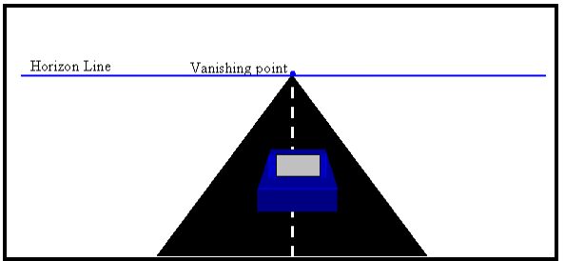
You will recall that Perspective is based on the concept that objects will appear smaller the further they are from the viewer. You will further recall that at some point along an imaginary line we call the Horizon Line that all objects will appear so small that they simply disappear. This point on the Horizon Line is called the objects Vanishing Point. This principle remains true whether we are talking about your character, your characters pet, or your characters house. While it is possible for different objects to have different Vanishing Points on the Horizon Line depending on their angle to the viewer, the Horizon Line itself must remain constant.
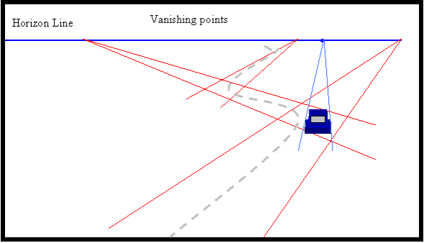
It is important to remember that the perspective of your characters and objects must match the perspective of the environment they are placed it. Imagine if you had a simple environment drawn in 1 point perspective of a road. The road will appear to become smaller as it recesses toward the horizon line. Now let's say you had a car traveling on one of that road away from the horizon line. To maintain proper proportion of the car with the road, you would have to maintain proper perspective as well. That means, in this case that both the car and the road will have to have the same horizon line and point at which they will appear to “vanish.”
That example works well for a straight road where the car is traveling straight down the road. However if our road was a curvy road, it may have a number of different Vanishing Points all along the same Horizon Line. To make it more complex, the Vanishing Points that we would use for our car would depend on where the car was on this curvy road. Yet no matter how complex our example becomes, the underlying principle remains the same. Objects that are close appear larger than objects that are further away. It is therefore important to note that the relative size of an object is one way we can develop depth in our environments.

Creating Realistic Depth
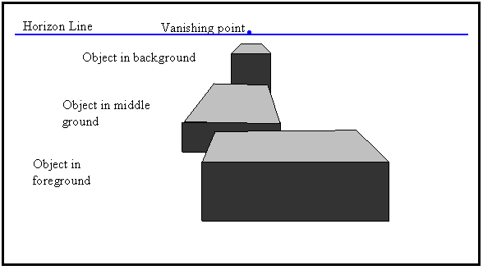
We have seen that developing the proper perspective in animation creates the feeling elements of depth in animated scenes. Depth can also be created by overlapping objects. Realistic depth depends on establishing three distinct areas in your environment: the foreground, middle ground, and background. Identifying these areas is a crucial part in developing believable environments and animations. Let's consider each one:
Foreground: Objects will be closest to the viewer, therefore will appear the largest. They will overlap the objects placed in the middle ground and background.
Middle Ground: These objects will be behind the objects in the foreground, but will overlap the objects in the background. They will vary in size depending on their distance from the viewer.
Background: Objects in the background are the furthest objects from the viewer. They are overlapped by the foreground and middle ground objects. In terms of animation settings, this also includes such things as the sky, land, walls, street, etc. of our environment.
The overlapping of objects in these three areas creates a strong feeling of depth within our environment.

Considering Depth in Animation
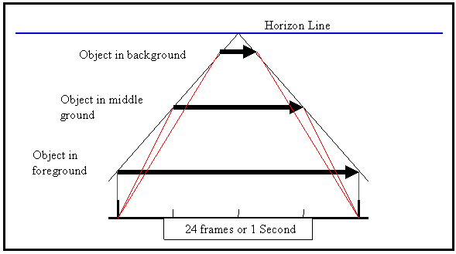
In animation, it is not only the relative size, proportion, and perspective of the environment that must be considered, but also the speed and timing of the objects in the animated sequence. The motion of an object in the background would appear relatively slow compared to that of an object in the foreground. You can see this illustrated when you are traveling in a car; the closer an object is to you, the faster it seems to go by.
The overlapping of objects in these three areas creates a strong feeling of depth within our environment.

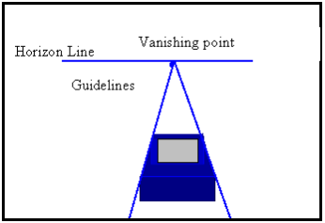
Understanding Z Depth
Using 2D imaging we are all familiar with the concept of X and Y coordinates. The exact placement of elements can be established in the image by determining its position along the vertical (X) axis and horizontal (Y) axis of the image. What we refer to as Z Depth adds another aspect to the positioning of elements in the image, that of stacking elements on top of each other. Z Depth is an imaginary line that runs between the background and the viewer; the positioning of objects along this line will determine its placement in the environment. When you work with layers in Photoshop, you are working with this same principle.
This principle also is evident when you look at the Guidelines you create in perspective. The Guidelines run between the object and its Vanishing Point on the Horizon Line. The closer the object is to the Horizon Line, the smaller it will appear. If we go back to our original drawing and examine one of the objects, we can see how this becomes evident.

Summary
This week, we looked at the methods of developing depth in our animation environments. We learned that depth is created by the relative size of the objects and by overlapping objects in the Foreground, Middle Ground, and Background. We learned that to create realistic animation is not just a matter of depicting these various layers in a scene, but also the timing of animating these various layers. We also learned that while we are using perspective principles, we are working with another principle used in animation call Z Depth. While we primarily simply reviewed and introduced the concepts this week, these same concepts will become very important to you as you progress through various courses and curriculum of the program.
Assignment 1: Discussion Question
The importance of environment is evident in the world around us everyday. Observe and sketch the environment around you either inside or outside. Find a view that shows a clear Foreground, Middle Ground, and Background. Post your sketch to the appropriate Discussion Area by Tuesday, April 28, 2009, along with your response to the discussion questions assigned to you by the facilitator.
Review the postings of at least two other students and post your comments to the appropriate topic in this Discussion Area as early in the week as possible.
Assignment 1 Grading Criteria | Maximum Points
Correct spelling and grammar | 4
Arrived at well formed conclusions supported with valid reasons | 4
Discussions reflected the understanding of the content | 4
Provided are meaningful, clear, and concise responses | 4
Actively participated in class discussions and gave constructive feedback and comments for at least two responses posted by other participants | 4
Total: | 20
For assistance with any problems you may have when completing this assignment—OR—to offer your assistance to classmates, please use the Problems and Solutions Discussion area located through the left side navigation link.
DQ 1 - Environments will often have more than one layer of Middle Ground. How many layers do you find in your sketch? Point out the objects in each layer.
DQ 2- When you look at your sketch, is there a primary method you used to create depth? Did you use overlapping? Did you rely primarily on perspective? Why did you choose this method?
DQ 3 - When do you think depth and perspective would be an important consideration in 3D games? Can you give an example of a game where this is true?
DQ 4 - Give an example of a 3D game you have played that you think makes good use of Overlapping imagery. How does it, and why do you think so?
Assignment 2: Master Project Part 5: Developing an Environment
In this assignment you'll create an environment for your character.
By Thursday, April 30, 2009:
Create an environment that will be appropriate to one of your characters. This can be either your protagonist or your antagonist character. Your environment should meet the following requirements:
  - A discernable Foreground, Middle Ground, and Background
  - At least one object in each layer drawn in perspective
  - At least two overlapping objects showing depth
Post the sketches to the appropriate Discussion Area.
By the end of the week, review and discuss the sketches posted by at least two other students. Comment on the use of the material presented in this weeks lecture material, the use of perspective, and the use of overlapping to create depth, the appropriateness of the environment to the character. Post your comments to the appropriate Discussion Area.
Assignment 2 Grading Criteria: | Maximum Points
Clearly depicted the Foreground, Middle Ground and Background | 4
Uses correct perspective | 4
Includes overlapping objects in the environment | 4
Commented meaningfully on all the posted sketches | 4
Actively participated in the Problems and Solutions discussion forum | 4
Total: | 20
For assistance with any problems you may have when completing this assignment—OR—to offer your assistance to classmates, please use the Problems and Solutions Discussion area located through the left side navigation link.
Assignment 3: Master Project Part 6: Putting your Character into the Environment
By Saturday, May 2, 2009, refine your environment sketches based on the suggestions from your Facilitator and classmates. Incorporate your character into the environment created in the previous exercise and post it to the appropriate Discussion Area. The character should be placed in the environment using proper perspective and in proper alignment with the depth of the environment.
By the end of the week review the postings of at least two students, and post your responses to the appropriate Discussion Area.
Assignment 3 Grading Criteria: | Maximum Points
Refined the environment based on suggestions given | 4
Proper use of depth and perspective in placing the character | 4
Showed an understanding of the subject matter utilizing perspective, overlapping and depth in developing the image | 4
Showed a discernable Foreground, Middle Ground, and Background | 4
Created character sketches that were identifiable with the student's portrait | 4
Discussions reflected the understanding of the content | 4
Actively participated in class discussions and gave constructive feedback and comments for at least two responses posted by other participants | 4
Actively participated in the Problems and Solutions discussion forum | 4
Total: | 32
For assistance with any problems you may have when completing this assignment—OR—to offer your assistance to classmates, please use the Problems and Solutions Discussion area located through the left side navigation link.
Assignment 4: Observation Sketches
Continuous observation and sketching is the key to understanding movement in animation. Each week you will have a thread to post your sketches and comment on others. You will then have a chance to modify them before final submission in Week 6. By Saturday, May 2, 2009, each week create at least 6 sketches from observation of movement, gesture, and emotion.
Some suggestions to get you started thinking would be:
- Figure Walking
- Figure Running
- Figure Skipping
- Figure Jumping
- Hand Opening
- Hand making a Fist
- Animals and Pets
- Leaves Blowing in the Wind
- Baby Crying
- Child Laughing
- Child Playing
Be sure to turn in your sketches each week to get feedback. In Week 6 you will zip all your sketches and submit them with your Master Project. These sketches are worth 120 points in your Final Grade and will be added in to the total points of your Master Project.
Assignment 4 Grading Criteria: | Maximum Points
Observations Sketches | N/A  (Note: Grade for Observations Sketches will be incorporated into your Master Project)
Submit 6 sketches from observation per week
For assistance with any problems you may have when completing this assignment—OR—to offer your assistance to classmates, please use the Problems and Solutions Discussion area located through the left side navigation link.

